**ASSIGNMENT 06:**

You have a Jenkins master server and Jenkins slave-1

You have to create and deploy .war file on slave-1 itself, using Jenkins pipeline job.

**Step 1:** Created one Jenkins Master server, installed apache tomcat & Jenkins.

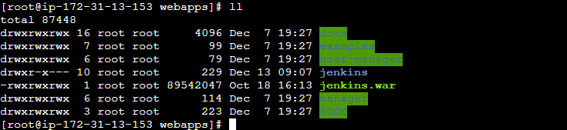

**Step 2:** Launched slave machine (slave-3) installed java-version 11, maven with zip file and apache tomcat on slave machine

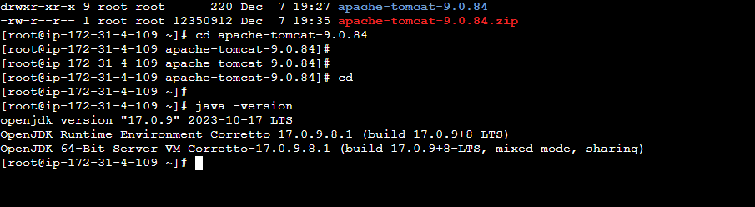

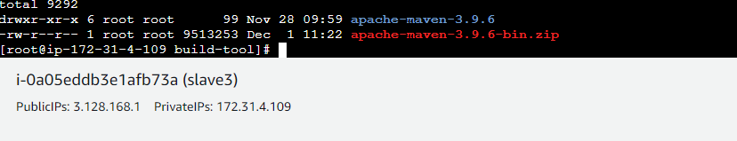

**Step 3:** Configured Jenkins Maser Slave connection using SSH method:

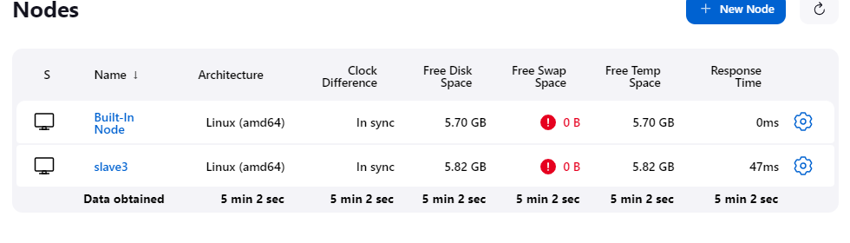

**Step 4:** Created a pipeline job:

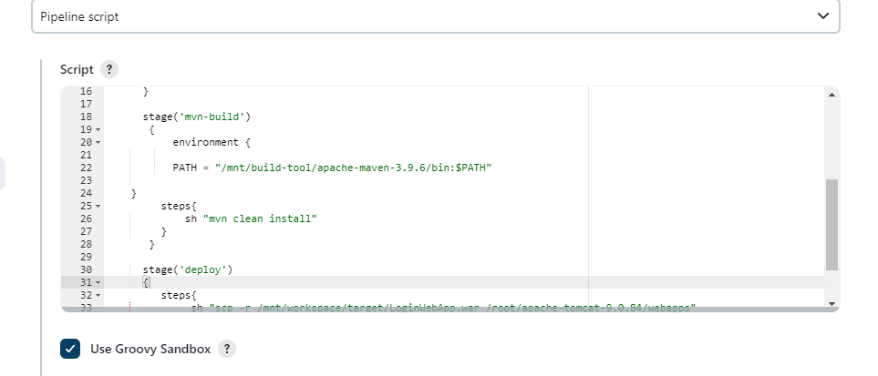

**IMP: Step5:** Set Environment variable go to root 🡪 ls -ltra 🡪 vi .bash_profile 🡪

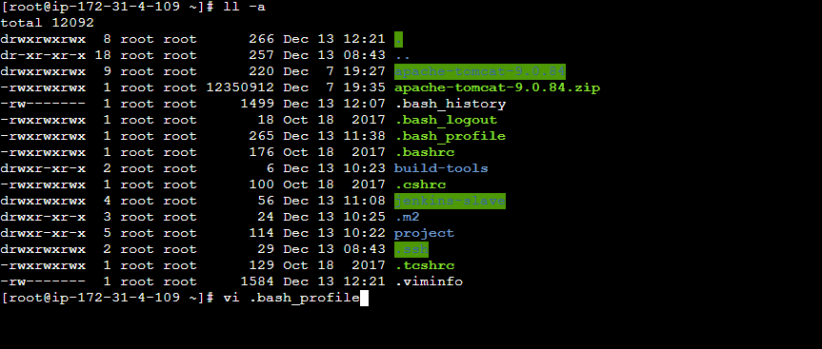

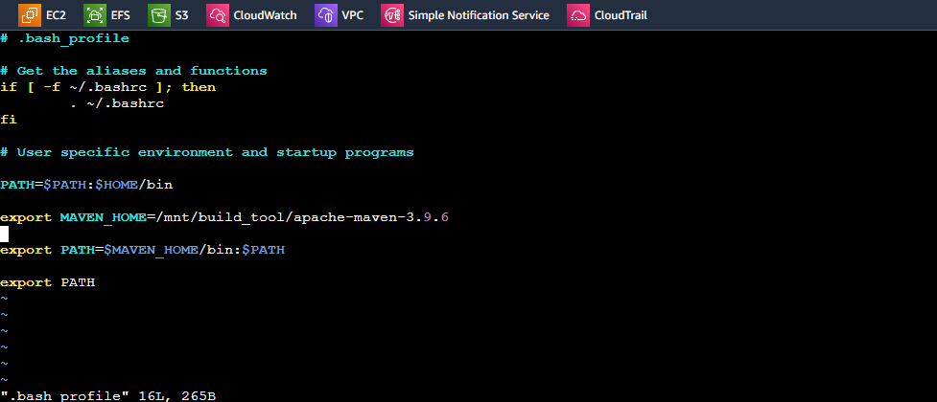

export MAVEN_HOME=/mnt/build_tool/apache-maven-3.9.6

export PATH=$MAVEN_HOME/bin:$PATH

**Script that I’ve created and used for this Pipeline Job**

pipeline{

agent{

label{

label "slave3"

customWorkspace "/mnt/workspace"

}

}

stages{

stage('git-clone')

{

steps{

git changelog: false, poll: false, url: 'https://github.com/Bamruta/project.git'

}

}

stage('mvn-build')

{

environment {

PATH = "/mnt/build-tool/apache-maven-3.9.6/bin:$PATH"

}

steps{

sh "mvn clean install"

}

}

stage('deploy')

{

steps{

sh "scp -r /mnt/workspace/target/LoginWebApp.war /root/apache-tomcat- 9.0.84/webapps"

}

}

}

}

**Successfully Executed Job**

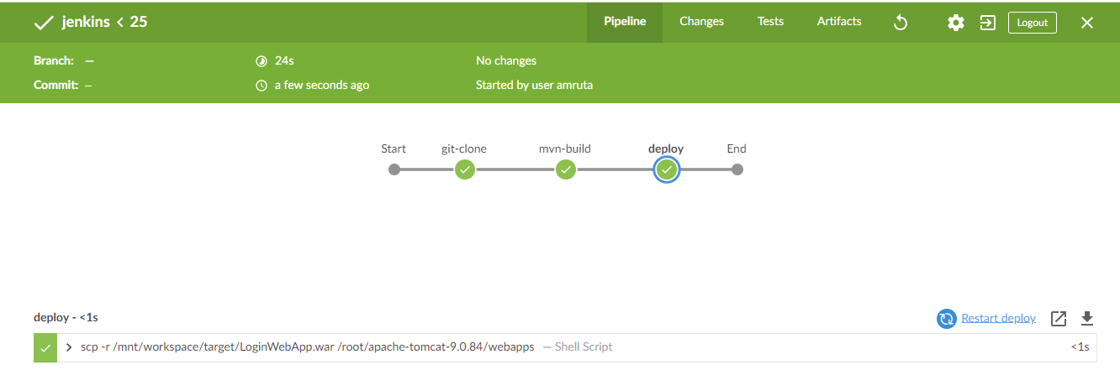

**OUTPUT**

